Prepare your code for a demonstration including:
- mining and coin creation
- fork resolution
- transaction resending protection
- payments between miners and SPV clients
  - transaction validation (for miners and SPV clients)
- the attacks from the previous week
Conduct a demonstration and prepare a document reporting on it. In your report please also document how to reproduce your demonstration and highlight major differences between Bitcoin and your SUTDcoin.

Team: KDCoin
Clemence Goh (1002075)
Delbert (1002374)
Kenneth (1002215)

Demonstration

Mining, transaction resending, and payments
- Start MinerApp, MinerApp2, spvClientApp and trustedServer
- Start test_two_miners_one_client() from e2e_test

Explanation:
- Miners 1 and 2 are created and initialised with 100 coins each.
- Miner 1 creates a transaction to Client 1 of 100 coins, and broadcasts it.
- Miner 2 receives this transaction from Miner 1 and starts to mine it into a block.
- Since every miner is connected to each other, no resending of the transaction is required.
- The test case then gets the Client to send a payment of 10 coins to an arbitrary random new person
- Miner 1 and 2 again builds the block from the transaction and resolves the blockchain
- At the end, the client should be left with 90 coins.
- The balance of the Miners are unknown since there is no way of knowing who will mine the block first beforehand

Selfish-mining, fork resolution:
- Start HackerApp, MinerApp, and trustedServer
- Start test_selfish_mining() from e2e_test

Results:
- MinerApp:
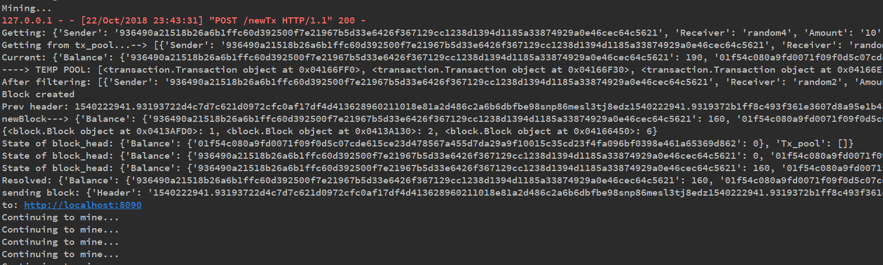
- HackerApp:
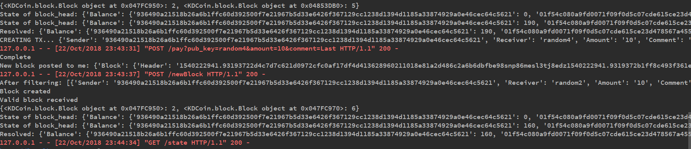
- Test Results:
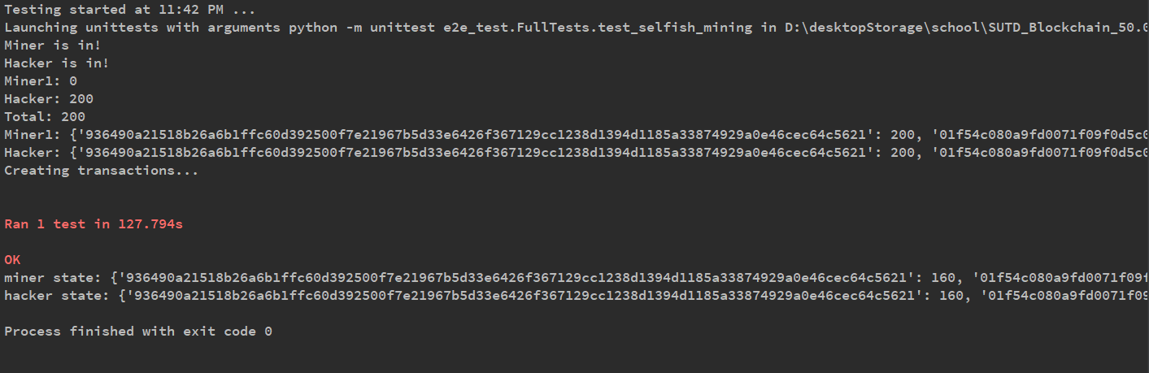
- Explanation:
  - Miner and Hacker are both initialised
  - Hacker completes blocks with difficulty of 2 while Miner has to complete with difficulty of 4 to simulate a greater computational power on the Miner’s end.
  - 1 empty transaction is posted to each miner and hacker to give them the opportunity to have 100 coins in their account
  - Subsequently, 4 transactions are broadcasted to both accounts.
  - As the hacker forms blocks, he stores them away in a list and waits for someone else to broadcast their block.
  - As the miner completes a block and attempts to broadcast it, the hacker receives the block, adds it to his own list of blockchains, and broadcasts all blocks he had stored up with him in the time it took for the miner to broadcast his block.
  - Fork is created at this point, with Miner holding on to 2 blockchains of different lengths.
  - Both Hacker and Miner resolve the new blockchains, ending up at the blockchain of length 6 created by the Hacker instead of length 2 created by the Miner.

Double Spending Attack:
- Start attackerApp, minerApp, trustedServer
- Run test_double_spending() from e2e_test

Explanation:
- Miner and attacker nodes are initialized.
- Attacker is guaranteed 100 coins since it is required for attacker to have the coins to spend on merchants.
- Miner creates some transactions to elongate the blockchain
- As attacker receives the transactions, he puts them into a cache.
- Attacker then sends 50 coins as payment to merchant 1, and ensures that the block is built.
- Attacker takes the cached transactions and starts to mine from there, broadcasting each block as he builds them, adding a transaction of 50 coins to merchant 2 after.
- Attacker then adds other payments to ensure that this second blockchain is longer
- Second block with payment to merchant 2 will be the current block in the state.

Key Differences between Bitcoin and SUTDcoin

Bitcoin | SUTDcoin
- Uses Unspent Transaction Output (UTXO) to determine balance | - Follows Ethereum, uses addr:balance for balance keeping
- Choose transactions based on transaction fees | - Choose blocks based on index in transaction pool  - No implementation of transaction fees.
- SPV Clients store block headers to verify transaction has been added to blockchain | - SPV Clients do not store block headers.  - Clients verify transaction has been added to blockchain by checking account balance.  - If transaction has been deducted from account balance, transaction has been successfully added.
- P2p network with miners arbitrarily connected to each other | - Every miner is connected to each other

Differences | Bitcoin | SUTDcoin
Balance Keeping/ Validating Transactions | - Uses Unspent Transaction Output (UTXO) to determine balance | - Follows Ethereum, uses addr:balance for balance keeping
Choosing Transactions to be included in Block | - Based on transaction fees included in transaction | - Choose transactions based on index in

